**WEKA**

**Mean Absolute Error:** 1.5835

**Note:** The mean absolute error is an average of the absolute errors. It is a measure of difference between two continuous variables.

**Q1: What is the equation for num_rings?**

num_rings = 0.8607 * sex=M, F +

10.5383 * diameter +

10.7251 * height +

8.9743 * whole_weight +

-19.769 * shucked_weight +

-10.6481 * viscera_weight +

8.7497 * shell_weight +

3.0551

**Note:** When sex= M or F we have to multiply by 1. Num_rings is not affected by ‘length’ attribute and depends only on the other 8 attributes. Negative coefficients on shucked_weight and viscera_weight indicates that num_rings decrease as these two values increase.

**Q2: Reopen the dataset and keep only these columns: length, diameter, whole_weight, num_rings. What is the equation now?**

num_rings = -11.8042 * length +

29.8645 * diameter +

0.6345 * whole_weight +

3.412

**Note :** When length increases num_rings decreases.

**KNIME**

**Q1: What is the linear equation? Compare to WEKA’s output. What parameters have similar coefficients?**

num_rings = -0.8249 * sex=I +

0.0577 * sex= M+

-0.4583 * length +

11.0751 * diameter +

10.7615 * height +

8.9754 * whole_weight +

-19.7869 * shucked_weight +

-10.5818 * viscera_weight +

8.7418 * shell_weight +

3.8946

height, whole_weight, shucked_weight, viscera_weight, shell_weight have similar coefficients.

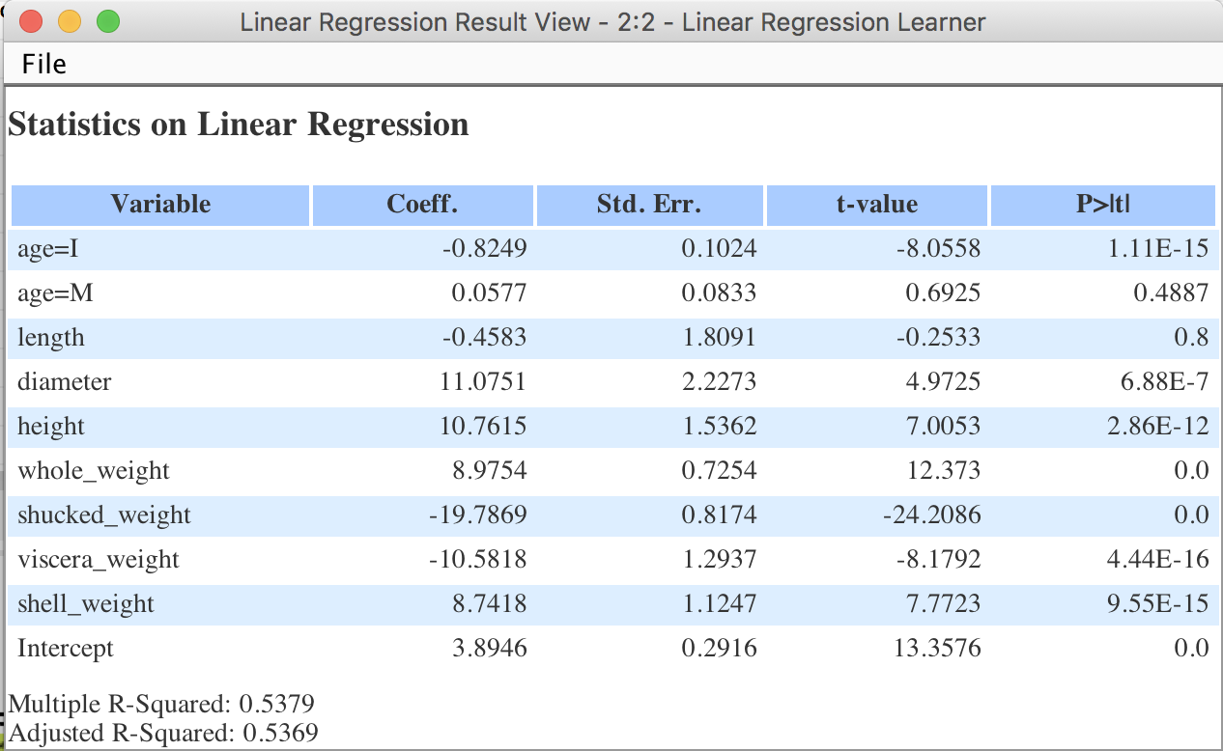

**Q2:** Set up a ‘Decision Tree Learner’ predicator, where ‘Sex’ is the predicted variable. Provide a snapshot of the entire decision tree.

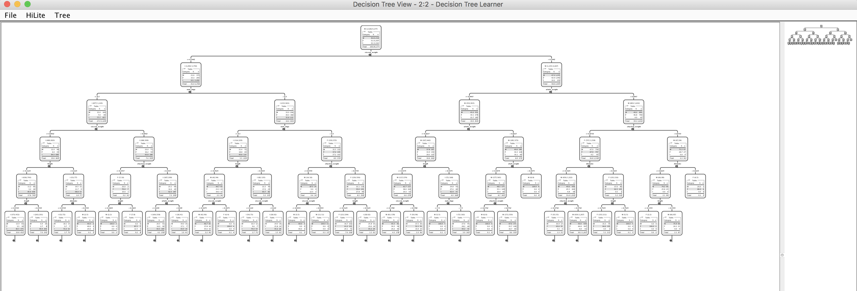

Right side pane view:

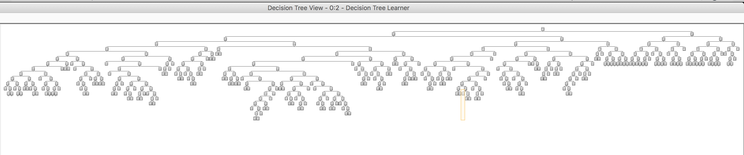

**BONUS QUESTION: RAPIDMINER**

**Q1:** How many data points are there in each cluster?

Cluster 0: 634 items

Cluster 1: 754 items

Cluster 2: 499 items

Cluster 3: 1257 items

Cluster 4: 194 items

Cluster 5: 839 items

Total number of items: 4177

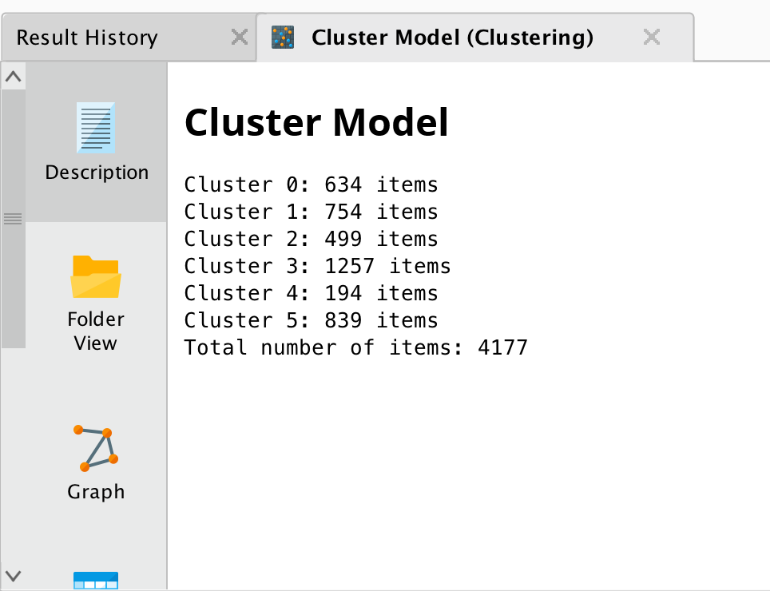

**Q2:** What is the linear regression equation?

Num_rings = -11.933 * length +25.766 * diameter + 20.358* height + 2.836

